What is safe programming?

HOW-TO note

For CSOs in humanitarian or development settings

How to Design and Deliver Safe Programmes

* Safe programming considerations should guide every CSO programme or project.   
  It one part of an organisation’s [safeguarding journey](https://safeguardingsupporthub.org/documents/safeguarding-journey-introduction-safeguarding).
* Safe programming emphasises CSO’s accountability to all community members and other stakeholders.
* Safe programming aims to make sure that   
  as far as possible community members are safeguarded from any intentional or unintentional safeguarding issues or risks that arise from how CSO programmes are designed and delivered. This may also include harm and abuse that takes place between community members, or within families, as a result of the programme.
* Safe programming does not include the general protection risks that arise within society that are unrelated to CSO work.
* In practice, safe programming includes identifying, assessing, mitigating and managing the risks of harm and abuse that may be caused by CSO programme design and delivery.

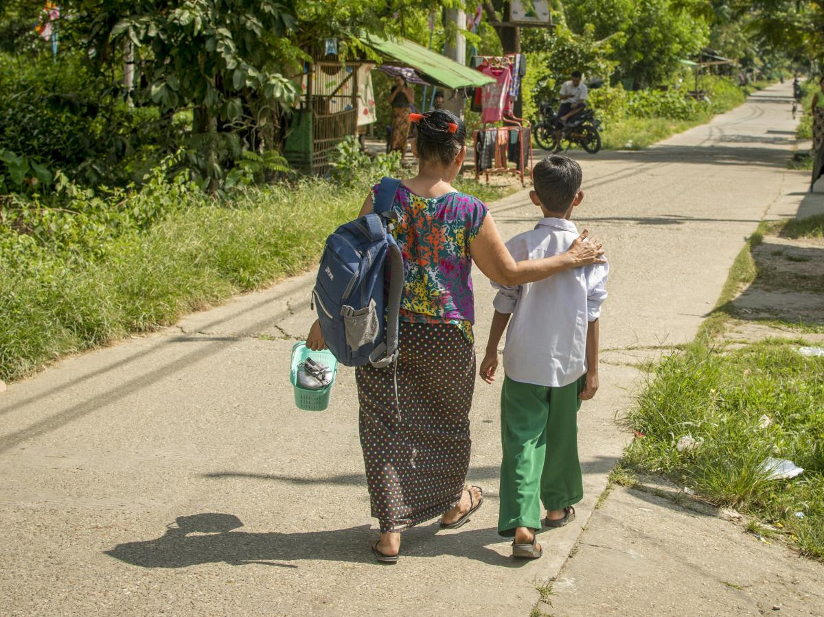

|  |
| --- |
| Who are we  keeping safe  through safe  programming?  **Anyone who may come across  your programme, including:**   * programme participants, * service users, and * other community members.   **Examples of what programme safeguarding risks or issues can  look like:**   * A male CSO staff touches a girl inappropriately while playing with her  as part of a psychosocial activity. * A female community volunteer representing a CSO gets a young man’s phone number from a programme WhatsApp group and sends him sexually inappropriate messages. * A boy walking to and from a CSO programme location is abused or harassed by community members  on that journey. * Community leaders asking a woman  to have sex with them in exchange for recommending a family for a CSO  cash for work scheme.   **For more, read:** [What is safeguarding?](https://safeguardingsupporthub.org/what-safeguarding) |

What do you need in place to support the safe design and delivery of programmes?

* Appoint a safeguarding focal point (SFP). Provide SFP(s) training so they can support colleagues to understand, monitor and manage safeguarding risks and respond   
  to reports.
* Ensure that all staff have received basic safeguarding training. Prioritise training for staff who will visit programme sites, including drivers and support staff.

At a minimum, staff should understand:

* their relevant organisational policies   
  and code of conduct,
* what safeguarding risks and issues are, with examples from their operating environment,
* how to identify safeguarding risks   
  and issues,
* how to respond appropriately to a report   
  of abuse,
* what the reporting channels are in their operating environment and how to use   
  them, and
* what a survivor-centred response is and why it is important.
* Complete a mapping of quality assured local support services and gaps (e.g. of financial, legal, psychosocial, medical, and child protection support). Make sure all staff can access the details.
* Develop a plan so urgent cases can be referred to support services. Identify alternatives where services are not in place. Identify resources to assist a victim or survivor to access services (e.g. with travel).
* Share information and your procedures related to safeguarding risks and issues with CSOs working in the same area as you. Expect and ask others to share the same with you. In some areas there may be an organised network – sometimes called a “PSEA Network” – to coordinate sharing.
* Ensure that any investigations will be conducted by trained investigators only and that survivors or victims are supported by skilled staff.
* Ensure that survivor or victim support is monitored during and after the investigation.
* Make sure that disciplinary procedures are clear for those who have caused harm and abuse to programme participants, service users or other community members.

|  |
| --- |
| Why is community engagement so important  for safe programming?  **Community engagement is the active participation of different groups within  a community. Community engagement at every stage of the programme cycle is key to safe programming for many reasons, including:**   * Communities, and different groups within communities, are best placed to identify what makes them feel safe and less safe. This is essential information to understand whether CSO programmes might cause harm and abuse within communities or increase the risk of SEAH or other forms of abuse. For example, in contexts where rates of  GBV are high, CSO staff may be able to more easily sexually exploit or abuse communities without it being recognised or reported as a concern. * Communities, and different groups within communities, can both identify risks that might arise from the programme and contribute ideas to mitigate those risks. For example, if a CSO is planning to build water points  in the community which are in isolated places and therefore risky for girls and women particularly to access – communities can suggest alternative locations which are safer. * Communities, and different groups within communities, are best placed to explain what, how, when, where and to whom they would feel most comfortable reporting abuse by an organisation. * By sharing information about expectations (including on reporting  and response), listening and responding to community input, CSOs can start to build trust. To submit reports, communities need to trust that the CSO is committed to keeping them safe, that the reporting mechanisms are safe and confidential and that reports will be handled in an appropriate way. |

How to integrate safe   
programming throughout   
the programme cycle

1. Programme Start-up

* Gather information on local factors and resources which may have implications for safeguarding e.g.: relevant laws; local culture, values and norms; community organisation; community power dynamics.
* Analyse how local factors and resources can support or need to be considered to design programmes that are as safe as possible.
* Put in place sufficient financial and human resources for safeguarding activities.

|  |
| --- |
| **Examples of local factors and resources that will need to inform programme start-up and design.**   * National law may require reporting to police before referrals to medical services. * Communities may have internal ways of managing SEAH reports/complaints. |

2. Programme Planning & Design

2.1. Identify and assess the safeguarding risks

* Identify safeguarding risks across programmes and analyse their potential impact and likelihood. Include a range of community members in the risk identification and analysis process.
* Organise your risk assessment into   
  categories, e.g.: location; service user /   
  target groups; programme / service type;   
  staff, partners and related staff; external communication; protection of data; and   
  other community members.
* Analyse the safeguarding risks for all community members, especially for the more at-risk groups.
* Identify staff and others associated with the programme (e.g. volunteers or community members representing the CSO) who have experience understanding and addressing safeguarding. They may be able to inform or support your safe programming focus.

|  |
| --- |
| **The impact and likelihood of safeguarding risks will be different for different groups.**  Women and girls generally face greater risk of SEAH than men and boys.  Individuals who experience discrimination based on factors such as disability, migration status, race, age and sexual identity are at additional risk and may be even less likely to report abuse or suspicions than individuals who do not have discriminating characteristics. |

2.2. Embed safeguarding risk mitigation strategies into programme design and planning

* Develop a risk mitigation plan and incorporate it into the programme design. Test or verify risk mitigation plans with community members and adapt where necessary.
* Create clear direction with measurable objectives, timescales, roles and responsibilities to deliver a safe programme.
* Incorporate a risk mitigation plan into the programme budget, include resources for urgent immediate assistance cases that   
  may arise.

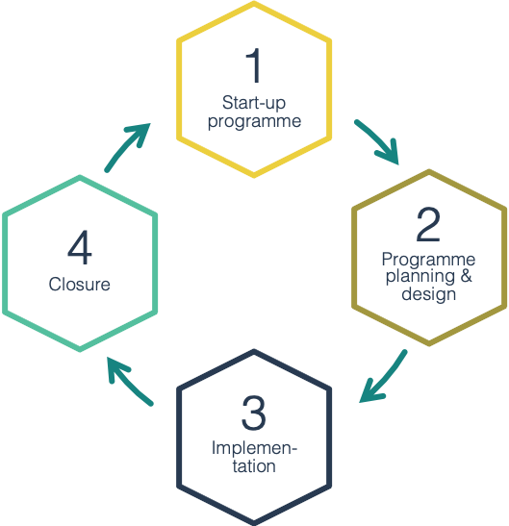

Engage with   
the community throughout your programme   
cycle

3. Programme Implementation

3.1. Establish community-based complaints mechanisms (CBCMs)

* With input from community members, create CBCMs that encourage, listen to and respond appropriately to reports of SEAH.
* Put in place different ways to report that are safe, confidential and accessible. Keep procedures simple and aligned. Note that reporting to someone face to face appears to be important.
* Identify any local CBCMs in place. Where existing CBCMs are deemed appropriate and are used by community members, use/build on the same system and create operating procedures with the other CSO(s).
* Avoid creating separate reporting systems for each CSO in one programme location. This may confuse procedures, obstruct trust and create challenges for victims and survivors.
* Make sure that community members across programme locations:
* understand what safeguarding is and what their related rights are,
* know what behaviour to expect from CSO staff and associates,
* know what they can report and how to report abuses/complaints, and
* know what to expect after submitting   
  a report.

3.2. Reach out to communities, show commitment to preventing and responding   
to safeguarding risks

* Use community meetings, monitoring meetings and community visits to communicate the importance of reporting any safeguarding incidents/concerns.
* Remind community members how CSO staff should behave and discuss safeguarding risks.

3.3. Provide survivor-centred response to reports, case handling and investigations

* When any staff member receives a report or witnesses a safeguarding incident, they should ensure safety, listen, respect, not discriminate and maintain confidentiality.
* Refer urgent cases to support services.
* Report all incidents to formal channels, senior leadership, donors and others as needed.
* Prioritise victim or survivor wellbeing and safety throughout case handling process.
* **Only where information does not identify an individual or group**, provide anonymous feedback to communities on reports and response procedures. This must be done with extreme caution to avoid further harm or abuse of survivor(s) or victim(s).

3.4. Monitoring, evaluation and learning (MEL)

* Systematically review the safeguarding risks. Embed any new risks into the mitigation plans.
* Regularly ask different groups in the community if the CBCMs are fit for purpose and accessible (especially if reporting is low).
* Make MEL activities safe and ethical, e.g.:
* Enable participants/service users to give informed consent if sharing information,
* Store and use data securely, and
* assess and mitigate safeguarding risks of MEL tools and procedures.

4. Programme Closure

* Review safe programming performance.   
  Share lessons for future programmes.
* Report outstanding safeguarding concerns/incidents   
  prior to completion.
* Build safeguarding into the programme if   
  it is being handed over to another organisation.