A community-based complaints mechanism (CBCM) is:

How to Set up and Manage a Community-based Complaints Mechanism

For CSOs in humanitarian or development settings

HOW-TO note

* A way for communities to raise concerns or provide feedback to a CSO.
* A way for CSOs to listen to feedback and complaints from community members and respond in a timely, confidential and impartial manner.
* Feedback or complaints on various topics can come through a CBCM, including programme services or procedures, fraud or corruption, or on sexual exploitation and abuse (SEA).
* A CBCM includes a range of safe, accessible, appropriate channels for all community members.

A CBCM requires a cross-organisational approach

An effective CBCM needs input from different activities and areas of work within a CSO:

* Programme monitoring, evaluation and learning (MEL) activities
* Community engagement efforts
* Ways of working with partners
* Financial and audit procedures
* 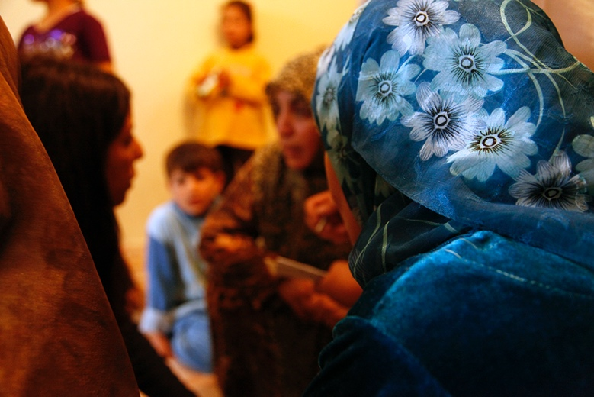Human resources procedures

|  |
| --- |
| Top tips for getting started   * Set up a CBCM and encourage use for the lesser complaints and feedback first. * Then add SEA to the list of what can be reported through the mechanism.   This gives people across a community the opportunity to test the mechanism on lesser issues and to build trust and confidence in it.    As you are designing a CBCM, remember:   * It is the CSOs, not the affected population, who need to adapt their ways of working to enable a useable reporting system. * Do not place the burden of understanding what, how, to whom to report onto the affected population. |

10 steps to setting up a CBCM

1. Secure leadership commitment within your CSO to seek and act on complaints/reports.
2. Agree an internal process for handling reports when they come in. Who is responsible for what? Which areas of work will lead what?
3. Complete a mapping and quality assurance of local support services and gaps (e.g. of financial, legal, psychosocial, medical, child protection support, law enforcement/police). Make sure all staff can access the details. Develop a plan so urgent cases can be referred to support services. Identify alternatives where services are not in place.
4. Train all staff to receive and handle reports.
5. Understand how other CSOs working in the same area are seeking and acting on complaints/reports. There may be a local, organised network – sometimes called a “PSEA Network” – for general learning and sharing purposes. Where possible and relevant, identify other CSOs to create a shared CBCM with. Try to avoid creating different CBCMs for each CSO or project within one community.
6. Explain to the affected population that CSO staff and programmes should not cause SEA or other harm. Explain the CSO’s intention to ensure accountability through the CBCM and the intention to respond to all reports / complaints received.
7. Consult with different members of the affected population on how they would like to report. Analyse and consider:
   * existing community structures and reporting mechanisms,
   * communications channels and languages that the affected population likes, uses and trusts, and
   * reasons why different individuals or groups may not report.
8. Decide how to appropriately feed back to the community on a report response. This will vary according to type of report/complaint, priority, confidentiality and anonymity.

|  |
| --- |
| Different groups and individuals may prefer different reporting channels.  One CBCM should include different reporting channels.  **Channels for affected populations to report SEA can include:**   * Women and Girls Friendly Spaces * Child Friendly Spaces * Suggestion boxes * Verbal complaints * Community training, participation and reporting * MEL activities |

1. Set up your channels for affected populations to report. Consider appropriate channels for SEA reports that are safe and confidential.
2. Raise awareness with the affected population about your CBCM. Be reactive (discuss when an opportunity arises) and proactive (set meetings). Make sure that community members:

* understand what safeguarding is and what their related rights are,
* know what behaviour to expect from CSO staff and associates and what is prohibited,
* know what they can report and how to report abuses/complaints, and know what to expect after submitting a report.

Maintaining a CBCM

* Respond appropriately to all reports/complaints, including any received through informal channels e.g. driver told.
* Continue to raise awareness with all members of the affected population.
* Regularly ask different groups if the CBCM is fit for purpose and accessible (especially if reporting is low). Adapt or establish new channels where systems are not used or trusted.
* Document and share lessons, e.g. most used channels.